**NAME…………………………………………………………………………. TARGET MARK ………………………………**

**P530/1**

**BIOLOGY**

**21/2 HRS**

**END OF YEAR EXAMNATION 2019**

**S.5 BIOLOGY P530/1**

**TIME:2HRS 30MINS**

**INSTRUCTIONS:**

* **Attempt all questions in section A and B**
* **Answers to section A must be filled in the boxes in front of the question in paper provided.**
* **Answers to section B must be written in the spaces of the question paper provided.**

**SECTION A (40 MARKS)**

1. Which one of the following processes of meiosis 1 results into genetic variability within a population?
2. Diplotene
3. Zygotene
4. Pachytene
5. Leptotene
6. Which of the following is incorrect about pinocytosis?
7. It involves use of energy in form of ATP
8. Involves removal of bulky materials from the cell
9. It involves in folding of the cell membrane
10. It involves pinching off resides from the cell membrane
11. During chemiosmotic synthesis of adenosine triphosphate
12. Hydrogen ions diffuse from the matrix to the inner- membrane space
13. Energy in form of ATP is formed at the matrix
14. Hydrogen ions diffuse from the inter- membrane space to the matrix
15. Energy in form of ATP is formed at the inter- membrane space
16. Which of the following is the significance of nitrification towards nitrobacter?
17. To obtain oxygen for their respiration activities
18. To obtain organic food substance for their growth
19. To obtain energy for their food synthesis
20. To increase the level of nutrients in the soil
21. Which one of the reactions bellow does not occur within the cytoplasm of the mesophyll cells of C4 plants?
22. Conversion of malate to pyruvate
23. Conversion of phosphenol pyruvate to oxaloacetate
24. Conversion of oxaloacetate to malate
25. Conversion of pyruvate to phosphenol pyruvate
26. Which one of the following is true about oleic acids?
27. They have low melting point
28. They have maximum number of hydrogen atoms
29. They lack double bonds
30. They are a minor constituent of olive oil
31. Which one of the following is not true about protoxylem?
32. It is capable of stretching
33. It is less lignified
34. It exists after cell elongation
35. It is dead tissue
36. Which one of the following transfers of energy in an ecosystem the greatest loss of energy occurs?
37. Sun to primary producers
38. Primary producers to primary consumers
39. Primary consumers to secondary consumers
40. Secondary consumers to tertiary consumers
41. Which of the following plant chemicals is more useful in enabling survival of the adverse conditions environmental conditions by the plants?
42. Auxins B. Abscisic acid C. Cytokinins D. Gibberellic acid
43. Which one of the following is not true about compound X with a molecular formula C5H10O4?
44. It is a reducing a gent
45. It forms a nucleoside together with a nitrogen
46. It is a component of mRNA
47. It can form crystals.
48. How many water molecules are produced when 30 molecules of glycerol are to synthesize trighycerides?
49. 15
50. 30
51. 60
52. 90
53. Which one of the following stimulates the pancreas to secret bicarbonate ions?
54. Enterocrinin
55. Secretin
56. Cholecystokinin
57. Enterogastrone
58. Which one of the following is not in the xylem tissue?
59. Vessels and tracheid
60. Fibres
61. Companion cells
62. Parenchyma cells
63. Which one of the following is the biggest contributor of electrons to the electron transport system?
64. Oxygen
65. Glycolysis
66. The Kreb’s cycle
67. Transition reaction
68. Which one of the following is best location of the pace maker of mammalian heart?
69. Ventricular spetum
70. Wall of the auricle
71. The right auride
72. Near the bicuspid valve
73. Facultative anaerobes
74. Require constant supply oxygen
75. Are killed in an oxygenated environment
76. Do not always need oxygen
77. Are photosynthetic
78. In which animal is circulatory system not involved in gas transport?
79. Mouse
80. Dragon fly
81. Trout
82. Sparrow
83. Which one of the following hormones is secreted by the neuro sectory cells in mammals?
84. Adrenaline
85. Antidiuretic hormone
86. Insulin
87. Thyroxine
88. The myelin sheath and the diameter of the axon of a neuron are import in that they
89. Increase the speed at which impulses are transmitted
90. Enable impulses to be transmitted from one node of ranvier to another
91. Maintain a constant strength of each impulse
92. Allow quick exchange of ions
93. The phenomenon by which the activity of different organisms is by the length of light or darkness is
94. Migration
95. Phototropism
96. Photosynthesis
97. Photoperiodism
98. Chloride ions are vital for efficient functioning of salivary amylase because the ions
99. Are co-factors
100. Are co-enzymes
101. Are activators
102. Form alkaline solution
103. What would happen to a plant if it lost the cuticle from its leave due to an air pollution?
104. The plant would absorb too much light
105. Too much oxygen would be lost by the plant
106. Chlorophyll would leak out of the plant
107. The plant would lose water rapidly
108. Secondary succession in progress would be illustrated by
109. The appearance of terrestrial plants in a shallow pong undergoing silting
110. The appearance of lichen and mosses on a bare rock surface
111. Establishment of plants on a newly formed island
112. An abandoned farm and now covered with weeds and shrubs
113. Which one of the following forces is most effective in raising water to the top of the tall tree?
114. Adhesive force
115. Root pressure
116. Capillarity
117. Cohesive and adhesive forces
118. Of the following conversions, which one occur in humans under conditions of starvation?
119. Fatty acids to carbohydrates
120. Lipids to hip proteins
121. Glucose to lipids
122. Proteins to carbohydrates
123. What is common to the polysaccharides starch glycogen and cellulose?
124. They are all storage polysaccharide
125. They are highly branched polymer molecules
126. The monomer molecules in them are monosaccharides
127. Their monomer molecule is linked 1,4glycosidic.
128. Which one of the following metabolism is not endergonic?
129. Photosynthesis
130. Respiration
131. Protein synthesis
132. DNA synthesis
133. Enzymes that catalyse bond formation between two compounds using energy obtained from ATP hydrolysis are called
134. Ligase
135. Isomerase
136. Lyases
137. Transferases
138. The cell responsible for producing the ground substance in areolar tissue are called
139. Macrophages
140. Mast cells
141. Fibroblast
142. Fat cell
143. In the body proteins may combine with acids or bases depending on the
144. Temperature of medium
145. Hydrogen ions concentration in the medium
146. Number of solvent molecules present in medium
147. Number of amino acid molecules in the protein
148. Which one of the following is not a correct statement about nastic response?
149. The response may be growth movement
150. The direction of movement of a plant is always related to the direction of the stimulus
151. It is a response from non-directional stimuli
152. The response movements are localized
153. Long day plants may be stimulated to flower if
154. The period of darkness is interrupted with flashes of light
155. Provided with more than 10 hours of light
156. Provide with 12 hours of complete darkness
157. The light period is interrupted with short dark period.
158. Wearing a coarse shirt causes unpleasant sensation at first but later the discomfort disappears because
159. With continued stimulus, generator potential falls below threshold value
160. The post synaptic surface fails to release the transmitter substances
161. Nervous system stops carrying sensory impulses
162. Continued simulation leads to fusion of generator potentials
163. Muscle coordination during movement is a function of the
164. Cerebellum
165. Cerebrum
166. Medulla oblongata
167. Hypothalamus
168. In the colonization of a new area, the pioneer organisms are always
169. Fungi
170. Algae
171. Moses
172. Lichen
173. The transmission of impulses across synaptic cleft is caused by the
174. Sodium pump mechanism
175. Release of an acetylcholine
176. Depolarization by potassium ions
177. Release of cholinesterase
178. The action potential in a nuerone is caused by
179. Entrance of potassium ions
180. Leaving of sodium ions
181. Leaving of potassium ions
182. Entrance of sodium ions
183. The proteins property most important in creating molecular order in cell is
184. Tendency to form a colloidal state
185. Amphoteric property
186. The high molecular weight
187. Ability to form precipitates with strong acids
188. The relationship between the cellulose-secreting bacteria and the herbivorous mammals is an association called
189. Parasitism
190. Mutualism
191. Autotrophism
192. Commensalism
193. Which one of the following factors is density-independent on a population?
194. Floods
195. Predation
196. Food
197. Diseases

**SECTION B (60 MARKS)**

1. The diagram below represents three neighboring paramehyma cells. The figure shows the values of their water potential (Y)

1. (i) Using arrows shows on the diagrams the directions of net water movement between the three cells. (01 mark)

ii) Explain why the net movement of the water are as you indicate in an (i) above.

(04 marks)

………………………………………………………………………………………………………………………………………………………………………………………………………………………………………………………………………………………………………………………………………………………………………………………………………………………………………………………………………………………………………………………………………………………………………………………………………………………………………………………………………………………………………………………………………………………………………………

1. Explain why water can cross the cell membrane by diffusion but glucose needs a carrier protein. (04 marks)

………………………………………………………………………………………………………………………………………………………………………………………………………………………………………………………………………………………………………………………………………………………………………………………………………………………………………………………………………………………………………………………………………………………………………………………………………………………………………………………………………………………………………………………………………………………………………………………………………………

1. Give two supportive roles of water to animals and plants. (02 marks)

……………………………………………………………………………………………………………………………………………………………………………………………………………………………………………………………………………………………………………………………………………………………………………………………………………………………………………………………………………………………………………………………………………………………………………………………………………………………………………………………………………

42. Figure 4 shows a motor end plate together with associated muscle.

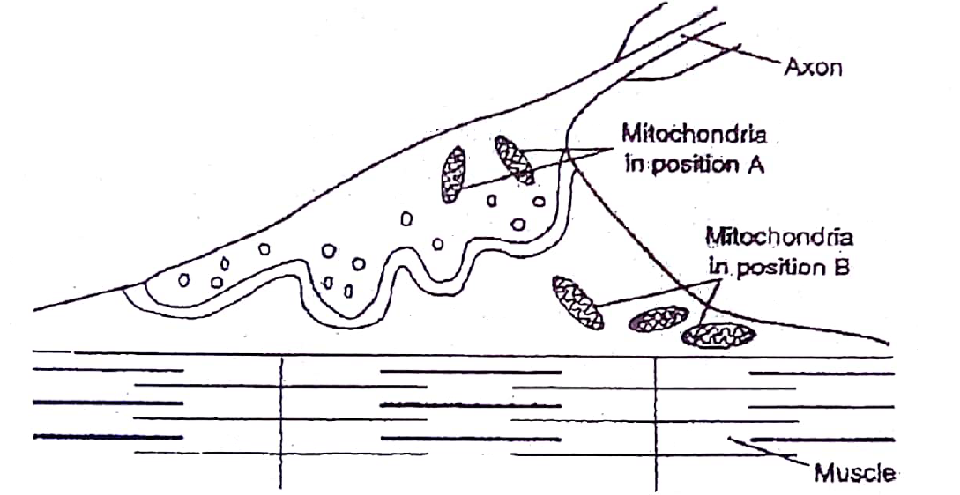

1. Describe how transmission of information occurs across the nerve muscle junction when an impulse arrives at the pre synaptic membrane (05mks)

………………………………………………………………………………………………………………………………………………………………………………………………………………………………………………………………………………………………………………………………………………………………………………………………………………………………………………………………………………………………………………………………………………………………………………………………………………………………………………

1. (i) What causes the banding pattern seen in the muscle fibril? (02mks)

………………………………………………………………………………………………………………………………………………………………………………………………………………………………………………………………………………………………………………………………………………………………………………………………………………………………………………………………………………………………………………………………………………………………………………………………………………………………………………

(ii) Explain the likely change in the banding pattern when the muscle fibril?

(03marks) ………………………………………………………………………………………………………………………………………………………………………………………………………………………………………………………………………………………………………………………………………………………………………………………………………………………………………………………………………………………………………………………………………………………………………………………………………………………

1. A graph below shows the relationship between discharge of hot industrial wastes into the lake and the percentage saturation of the water body with oxygen. Study it and answer the questions that follow.

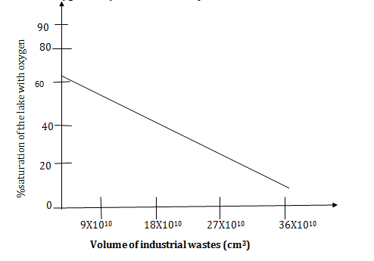

1. A comment on the relationship between % saturation of the lake with oxygen and industrial wastes, discharged into the water body.

(02marks)

…………………………………………………………………………………………………………………………………………………………………………………………………………………………………………………………………………………………………………………………………………………………………………………………………………………………………………

1. Account for the relationship mentioned in 43(a) above. (04 marks)

………………………………………………………………………………………………………………………………………………………………………………………………………………………………………………………………………………………………………………………………………………………………………………………………………………………………………………………………………………………………………………………………………………………………………………………………………………………………………………………………………………………………………………………………………………………………………………………………………………………………………………………………………………………………………………………………………………………………………………………………

1. Suggest two reasons why the % saturation of the lake with oxygen cannot be 100%. (02 marks)

………………………………………………………………………………………………………………………………………………………………………………………………………………………………………………………………………………………………………………………………………………………………………………………………………………………………………………………………………………………………………………………………………………………………………………………………………………………………………………………………

1. Suggest any two sources of oxygen in any aquatic ecosystem.(02 marks)

………………………………………………………………………………………………………………………………………………………………………………………………………………………………………………………………………………………………………………………………

44. (a) (i) Define the term respiratory quotient(RQ). (02 marks)

………………………………………………………………………………………………………………………………………………………………………………………………………………………………………………………………………………………………………………………………………………………………………………………………………………………

(ii) Glucose has the formula $C_{6}H_{12}O_{6}$ and tripalmitin has the formula $C_{51}H_{98}O_{6}$. These substances when completely oxidized have the following overall equations.

$$C_{6}H_{12}O_{6}+6O_{2}\underset{→}{ }{6CO}_{2}+6H_{2}O$$

$$C_{51}H_{98}O_{6}+\frac{145}{2}O_{2}\underset{→}{ }{51CO}_{2}+49H_{2}O$$

Using the above equation, calculate the RQ value for the aerobic respiration of tripalmitin.

($02\frac{1}{2}$ marks)

………………………………………………………………………………………………………………………………………………………………………………………………………………………………………………………………………………………………………………………………………………………………………………………………………………………………………………………………………………………………………………………………………………………………………………………………………………………………………………………………………………………………………………………………………………………………………………………………………………………………………………………………………………………………………………………………………………………………………………………………………………………………………………………………………………………………………………………………………………………………………………………………………………………………………………………………………………………………………………………………………………………………………………………………………………

(iii) State the RQ value of glucose in an anaerobic respiration. Explain how you arrive at your answer. ($02\frac{1}{2}$ marks)

………………………………………………………………………………………………………………………………………………………………………………………………………………………………………………………………………………………………………………………………………………………………………………………………………………………………………………………………………………………………………………………………………………………………………………………………………………………………………………………………………………………………………………………………………………………………………………………………………………………………………………………………………………………………………………………………………………………………………………………

(b) Distinguish between oxidative phosphorylation and photophosphorylation. (03 marks)

………………………………………………………………………………………………………………………………………………………………………………………………………………………………………………………………………………………………………………………………………………………………………………………………………………………………………………………………………………………………………………………………………………………………………………………………………………………………………………………………………………………………………………………………………………………………………………………………………………………………………………………………………………………………………………………………………………………………………………………………………………………………………………………………………………………………………………………………………………………………………………………………………………………………………………………………………

45. (a) What is meant by Kranz anatomy? (01 mark)

………………………………………………………………………………………………………………………………………………………………………………………………………………………………………………………………………………………………………………………………………………………………………………………………………………………………………………………………………………………………………………………………………………………………

(b) Briefly explain the photosynthetic dark reactions which occur inside the cytoplasm of the mesophyll cells in $C_{4}$ plants. (04 marks)

………………………………………………………………………………………………………………………………………………………………………………………………………………………………………………………………………………………………………………………………………………………………………………………………………………………………………………………………………………………………………………………………………………………………………………………………………………………………………………………………………………………………………………………………………………………………………………………………………………………………………………………………………………………………………………………………………………………………………………………………………………………………………………………………………………………………………………………………………………………………………………………………………………………………………………………………………………………………………………………………………………………………………………………………………………………………………………………………………………………………………………………………………………………

(c) Outline any three differences between the mesophyll and bundle sheath cells in $C_{4}$ plants. (03 marks)

………………………………………………………………………………………………………………………………………………………………………………………………………………………………………………………………………………………………………………………………………………………………………………………………………………………………………………………………………………………………………………………………………………………………………………………………………………………………………………………………………………………………………………………………………………………………………………………………………………………………………………………………………………………………………………………………………………………………………………………………………………………………………………………………………………………………………………………………………………………………………………………………………………………………………………………………………………………………………………………………………………………………………………………………………………

(d) Mention any two advantages of $C_{4}$ plants over $C_{3}$ plants.

………………………………………………………………………………………………………………………………………………………………………………………………………………………………………………………………………………………………………………………………………………………………………………………………………………………………………………………………………………………………………………………………………………………………

46. (a) What is meant by **active site** as applied to enzymes? (02 marks)

………………………………………………………………………………………………………………………………………………………………………………………………………………………………………………………………………………………………………………………………………………………………………………………………………………………

(b) State the role of active site in enzyme activity. (02 marks)

………………………………………………………………………………………………………………………………………………………………………………………………………………………………………………………………………………………………………………………………………………………………………………………………………………………………………………………………………………………………………………………………………………………………

(c) Explain each of the following characteristics of enzymes in relation to their structure.

(i) Specificity (03 marks)

………………………………………………………………………………………………………………………………………………………………………………………………………………………………………………………………………………………………………………………………………………………………………………………………………………………………………………………………………………………………………………………………………………………………………………………………………………………………………………………………………………………………………

(ii) Denaturation by heat (03 marks)

………………………………………………………………………………………………………………………………………………………………………………………………………………………………………………………………………………………………………………………………………………………………………………………………………………………………………………………………………………………………………………………………………………………………

**END**